Index:

- Road Accidents in India
- Road Accidents in Uttar Pradesh
- Online Articles of Accidents in Aligarh
- Visit to Police Control Room
- Visit to SP Traffic Office
- On field visits of various sites for problem identification
- Selected location
- Why we selected this location?
- References

- Road Accidents in India:
Road accidents are one of the main reasons for deaths and disabilities. With only 1% of the world’s vehicles, India accounts for 11% of the global death in road accidents, the highest in the world, witnessing 53 road crashes every hour killing 1 person every 4 minutes according to a report of the World Bank. This imposes the huge socio-economic cost on the country. This is more among the person of age group 16 to 45 years. At individual level, it imposes a severe financial burden.
A total of 3,54,796 road accident cases were reported during 2020. Road accident cases in the country have decreased from 4,37,396 in 2019 to 3,54,796 in 2020. The fatalities in road accidents have decreased by 13.9% (from 1,54,732 in 2019 to 1,33,201 in 2020).
It is observed that the rate of deaths per thousand vehicles in 2020 has declined from 0.52 in 2019 to 0.45 in 2020. 3,54,796 road accidents caused 1,33,201 deaths and injuries to 3,35,050 persons during 2020.
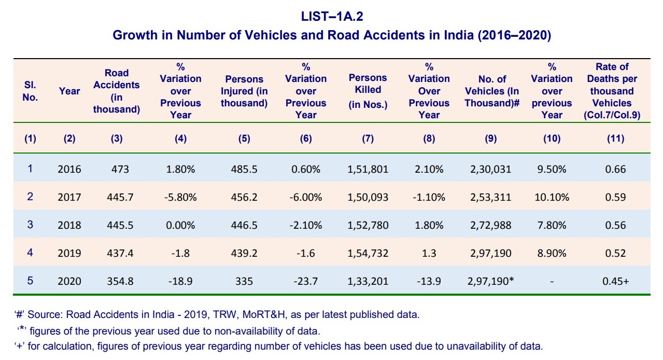
During 2020, two wheelers have accounted for maximum fatal road accidents (58,129 deaths), contributing 43.6% of total road accidental deaths, followed by cars (17,538 deaths) (13.2%) and trucks/lorries (16,993 deaths) (12.8%). The month-wise distribution of ‘Road Accidents’ shows that most of road accidents were reported in the month of January (38,866 cases), contributing 11.0% of total road accidents.
Cause-wise analysis of road accidents revealed that most of road accidents were due to over-speeding accounting for 56.6% of total accidents (2,15,159 out of 3,54,796 cases) which caused 75,333 deaths and injuries to 2,09,736 persons. Dangerous/careless driving or overtaking caused 86,268 accidents (24.3% of total accidents) which resulted in 35,219 deaths and injuries to 77,067 persons during 2020.
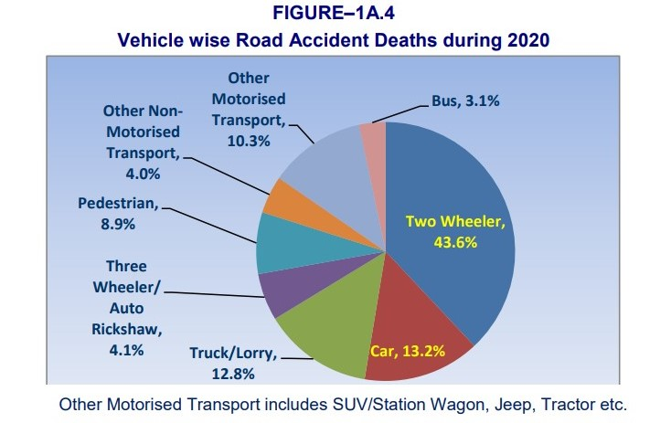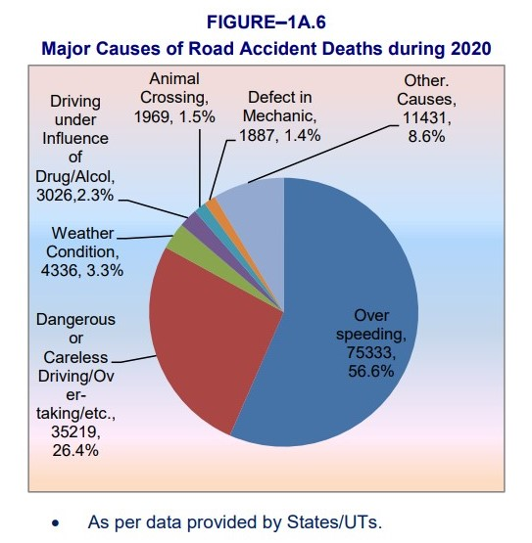
8.0% (28,226 out of 3,54,796 cases) of road accidents in the country have taken place near schools, college or other educational institutions.
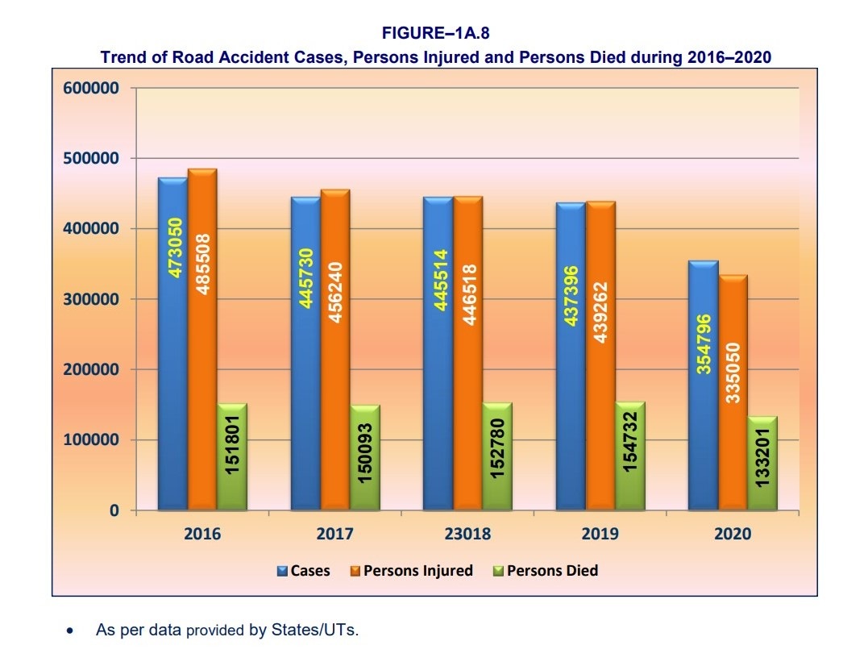
- Road Accidents in Uttar Pradesh:
Uttar Pradesh, road accidents caused more deaths compared to persons injured. In Uttar Pradesh, 28,653 road accidents caused 19,037 deaths and injuries to 15,982 persons.
Uttar Pradesh reported (5,735 deaths), accounting 9.9% of total deaths due to two wheeled vehicles. Large number of deaths due to car accidents (3,190 out of 17,538) were reported in Uttar Pradesh (18.2%) of total such accidents and large number of deaths due to trucks/lorries accidents (4,606 out of 16,993) were also reported in Uttar Pradesh, accounting for 27.1%. 17.7% (725 out of 4,098) of total fatal road accidents due to buses were reported in Uttar Pradesh.
Maximum fatalities in road accidents on the National Highways took place in Uttar Pradesh (13.6%) (6,137 out of 45,275 deaths). Maximum fatalities in road accidents on State Highways were reported in Uttar Pradesh (5,324 out of 33,824 deaths) which accounted for 15.7% of total deaths due to road accidents on State Highways, Maximum fatalities on the Expressways were reported in Uttar Pradesh contributing 60.8% (711 out 1,169).
Uttar Pradesh have reported 20.8% of total deaths due to road accidents near schools/college/other educational institutes in urban area respectively. Dangerous/careless driving or overtaking caused maximum fatalities in Uttar Pradesh (10,171 out of 35,219) which accounted for 28.9% of total deaths. Uttar Pradesh also reported highest fatalities due to road accidents at places near to residential area (urban area) accounting for 17.1% (2,581 out of 15,097) of total such deaths during 2020.
As per the MoRTH report, the maximum number of road accidents and deaths in UP are due to over-speeding. In the year 2019, there were 15,934 over speeding incidents causing death of 8,398 people. The second highest number of accidents in 2019, took place due to driving on the wrong side - 4988 accidents, which caused 2517 deaths. UP contributed the maximum number of over speeding deaths in the country that year. Another common reason for road accidents in UP is the use of mobile phones which caused 4,882 accidents and death of 2,969 people. This is also the maximum data in this category as against any other state in the country. Other causes of road accidents include drunken driving/consumption - 4496 accidents and 2,224 deaths, and jumping red lights which caused 874 accidents and 297 deaths.
- Online Articles of Accidents in Aligarh:

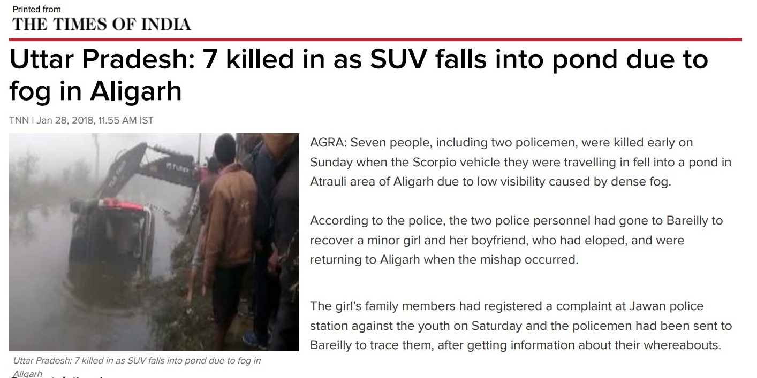

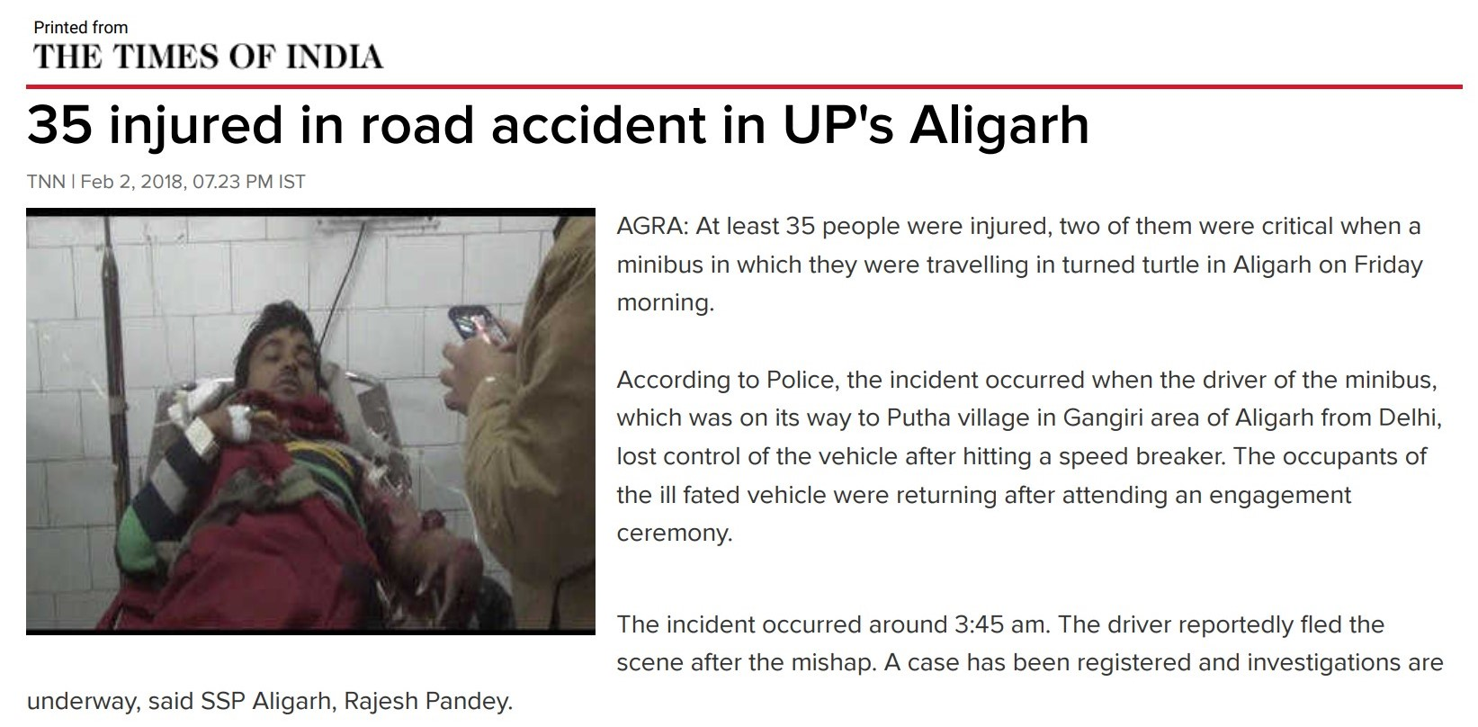

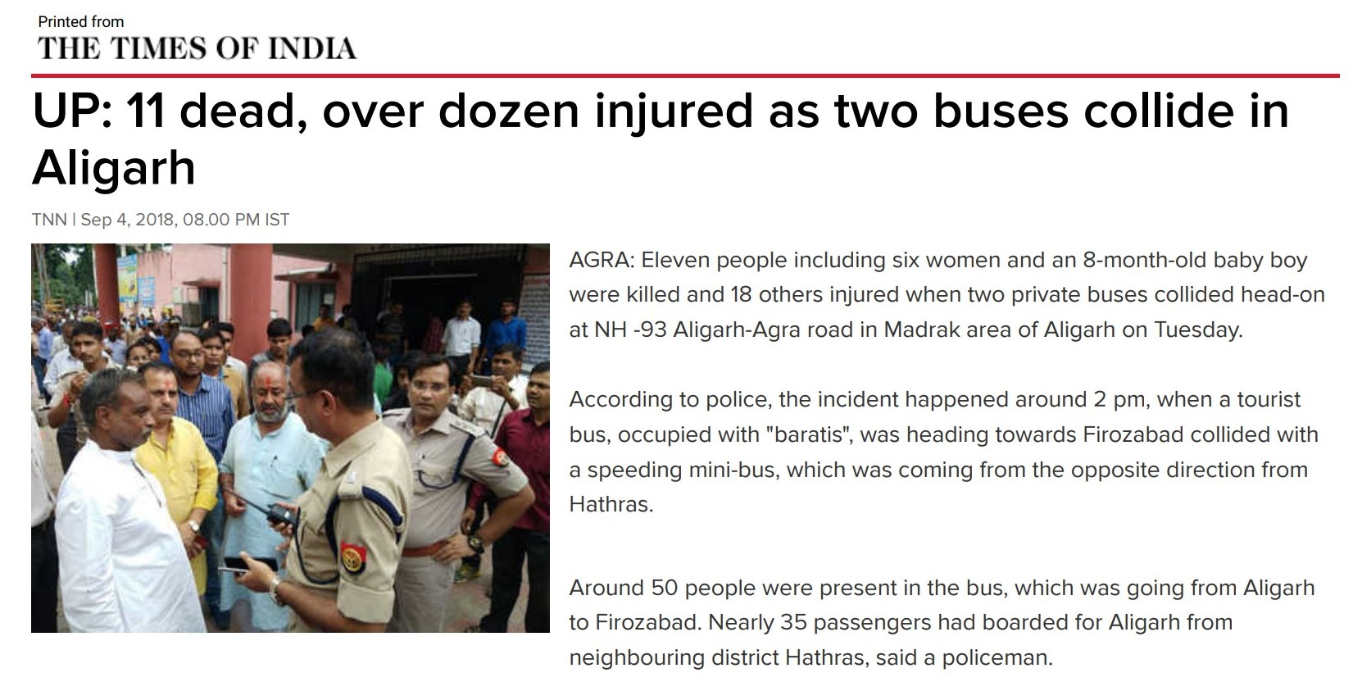
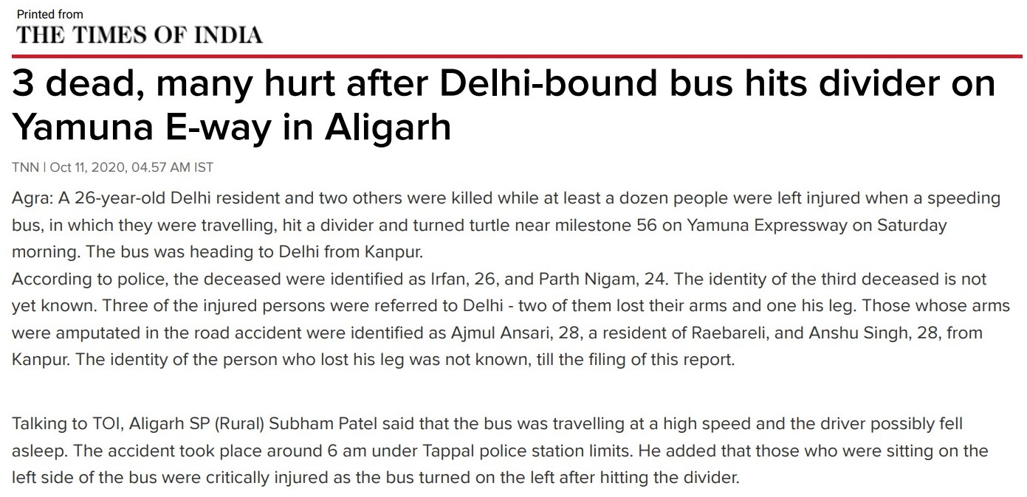
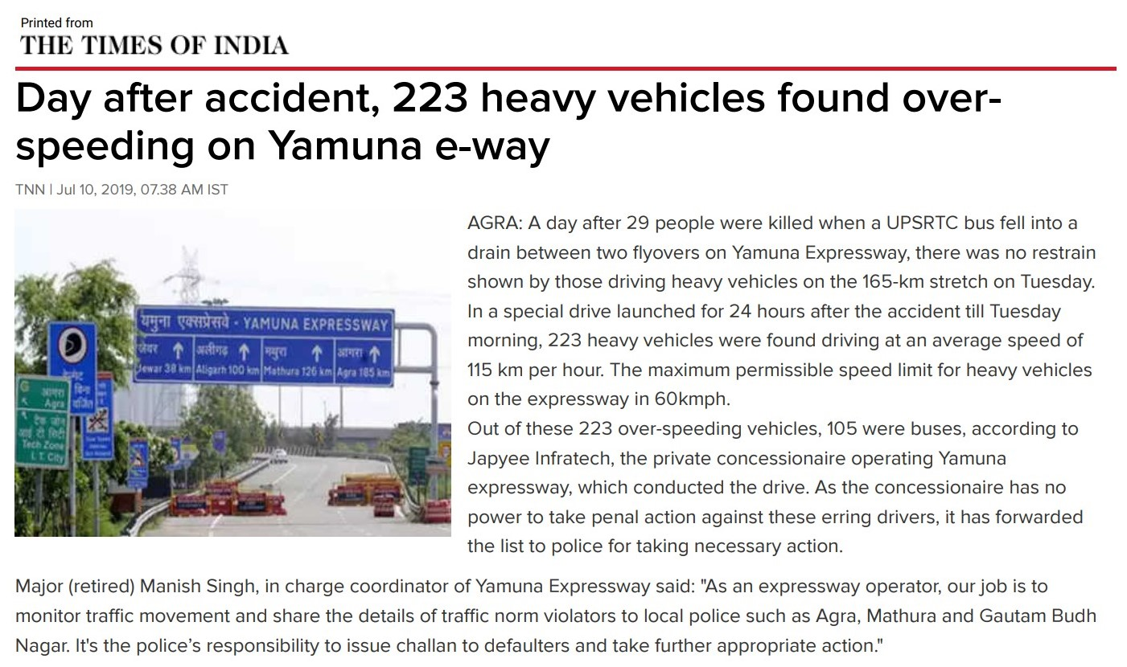
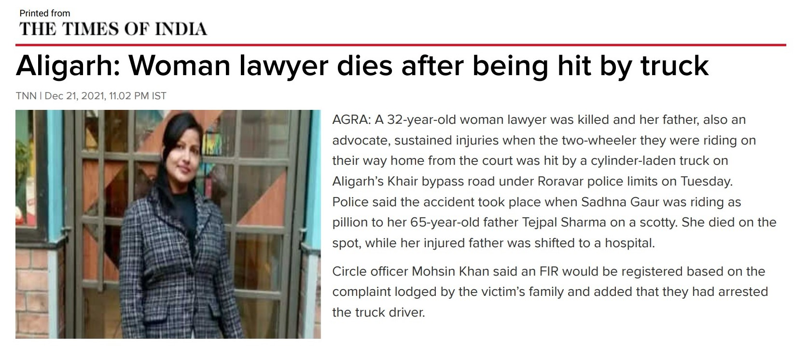

- Visit to Police Control Room:
After searching online for various road accidents in our city, we visited Police Control Room of our city to collect and collate our online data. We have also filed an RTI for major Black spots of district. According to road accidents data of Aligarh district, 881 road accidents happened in 2020 leading to 506 deaths and injuries to 807 persons. During 2021, 899 road accidents happened resulting in 503 deaths and injuries to 882 persons throughout district. We also got to know about some of the tagged locations on which the authorities are working.
We also visited JNMC for collecting accident data but it was disordered and raw. In start we did conversation with some stakeholders but dropped this plan later as it was unsmart to do.
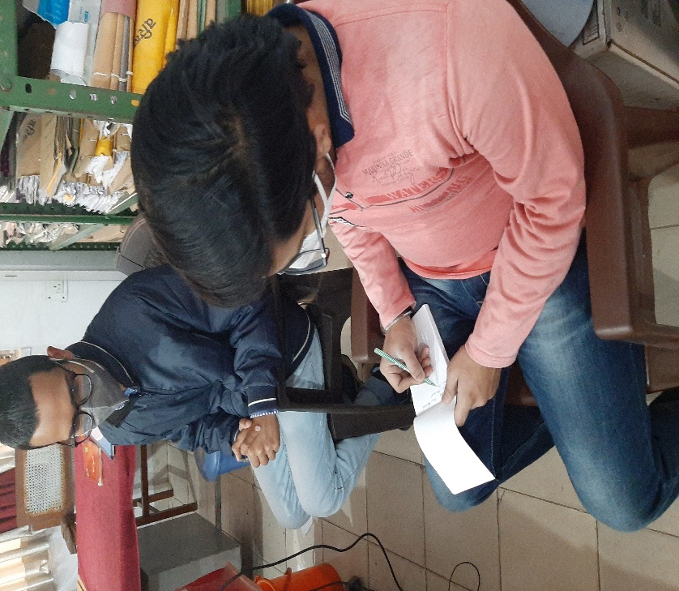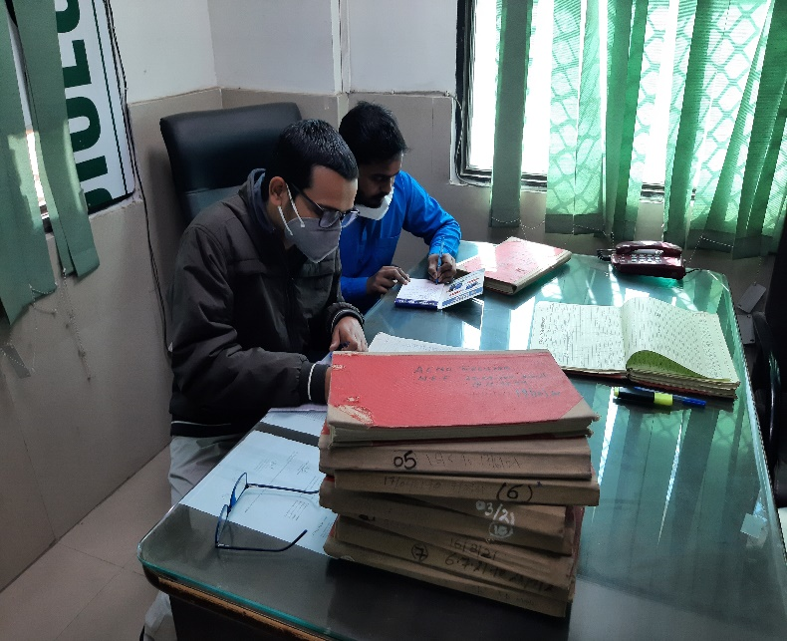
- Visit to SP Traffic Office:
We visited SP Traffic Office to collect data of the Aligarh city as the data we get from police control room is of the sub-divisions outside main city and are not feasible for us. We created region-wise list for the main city in which we classified different locations based on nearby Police Chowki. We also discussed about regions and road safety concerns with another team of IRSC Policy Internship and exchanged views and knowledge about it.

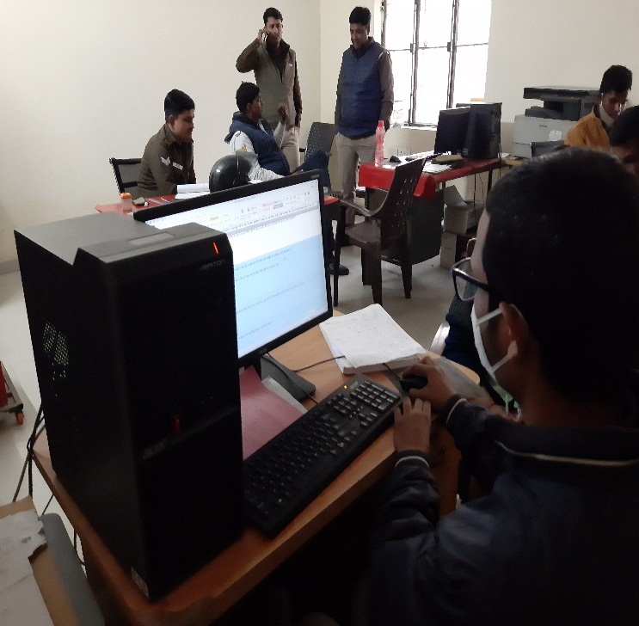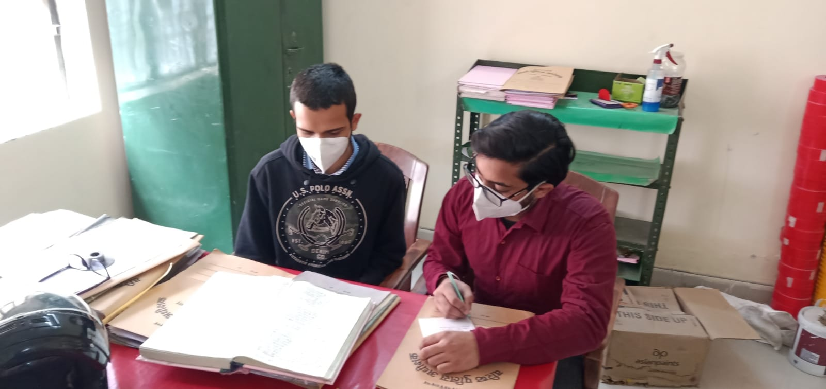

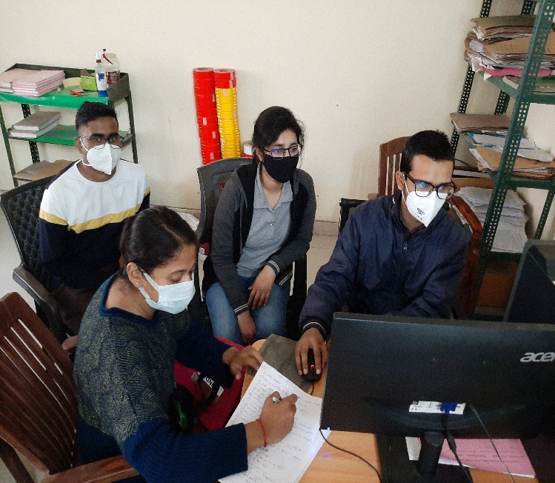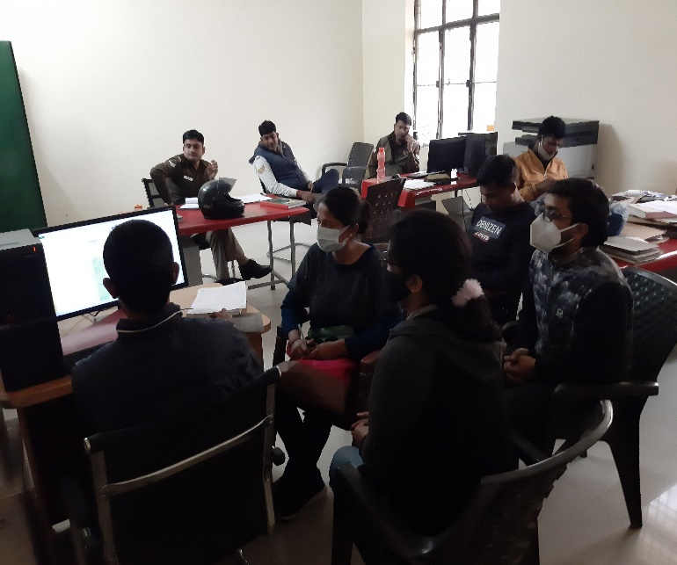

- On field visits of various sites for problem identification:
We started on field visits from Bannadevi Police Station. We talked with officials and get the required data of road accidents which we verified later from our data. According to the list, we visited various sites, collect data and discussed for the same with the stakeholders.
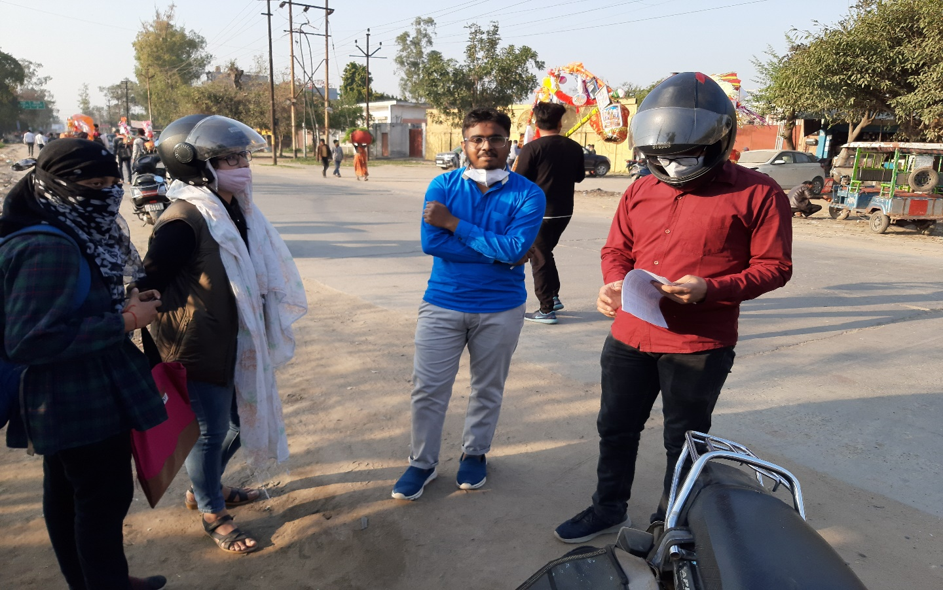

After visiting sites in Bannadevi region, we moved to Gandhi Park and Delhi Gate regions and visited Police Stations and repeated the same process. We also got advised from a officer at Delhi Gate Police Station and possible changes suggestions.
We also get to know about a Black spot at Khereshwar Chauraha and visited Roravar Chowki but due to new station we did not able to get data as it may not be present which we later get from RTI filed by us. From Online sources, we get to know about the proposed plan by NHAI to built a Flyover at Khereshwar Chauraha in a year or two.
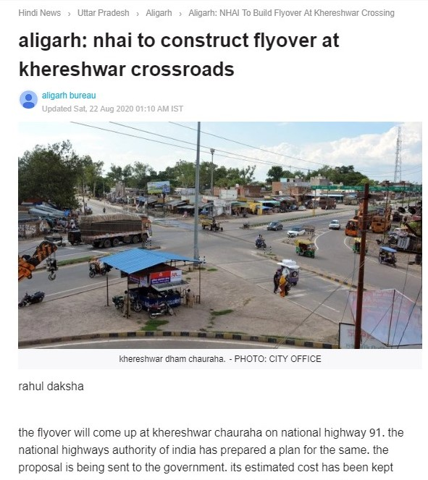
We visited Quarsi region and Quarsi Police Station the next day. We also visited an old Black Spot, Kayampur More, which was a deadliest spot once. Major work had been done there by the authorities and accidents have been reduced.
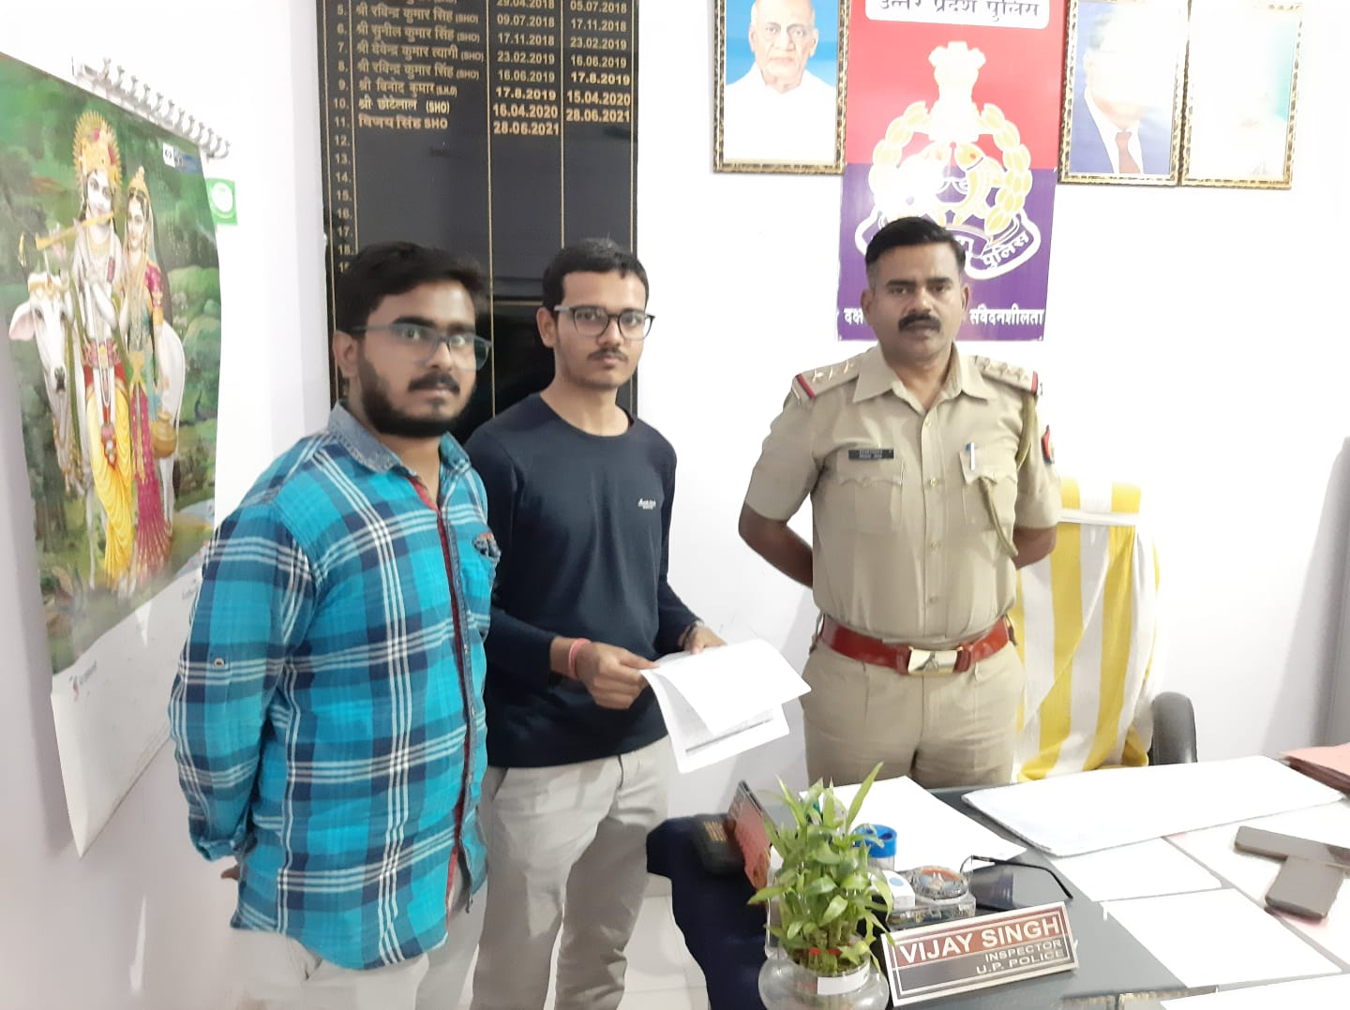
- Selected location:
Based on the response of stakeholders and a long discussion of team, Team decided to go with the location at Pt. Deen Dayal Hospital, Ramghat Road, near Quarsi, Aligarh.
- Why we selected this location?
The location selected by the team is based upon the observations that major places of accidents that are identified Black Spots have been worked upon by the authorities and places like Ramghat Road where accidents which are resulting in severe life-threatening disabilities or severe injuries may get less attention of authorities. Also, the selected location, has Wisdom Public School just near to it, which receives a fast-moving traffic from Quarsi Chauraha after a green light which make it more prone to accidents. The location also has vendors all around, not following prescribed markings due to lack of awareness about it, parked vehicles on road, public not following speed limits and vehicles moving in the wrong side leading to narrowing of roads. Few rickshaw and auto drivers also stop their vehicles at sudden which may lead to accidents. So, these are the reasons due to which we complied with this location for Road Safety.

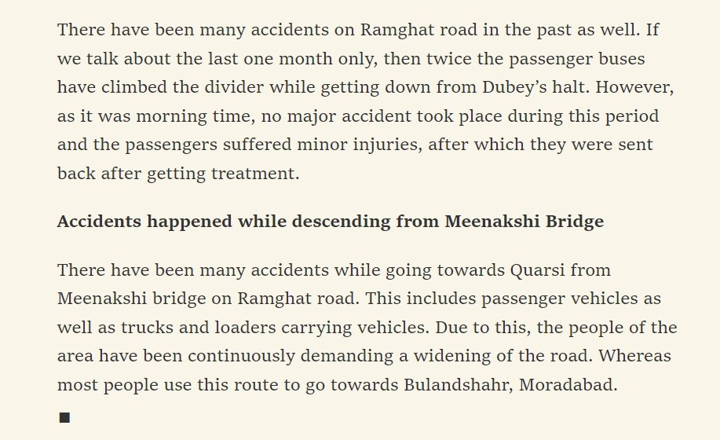

- References

- Report on Traffic Accidents in 2020 By NCRB, MoRT&H https://ncrb.gov.in/en/ADSI-2020
- The Times of India Articles https://m.timesofindia.com/topic/road-accident-in-aligarh/news

